Week2-session2-Tool selection/comparison
Tool 1- Google forms
Tool 2- HTML, CSS, JavaScript
Objective – quiz style game with feedback, scores and cyber safety questions
Google forms
- to create online surveys, quizzes, and forms to collect data, gather feedback and automate workflows
- Generates survey-style questions with comparable answers, simple layout/google-based layout structure, adequate number of questions are provided
- 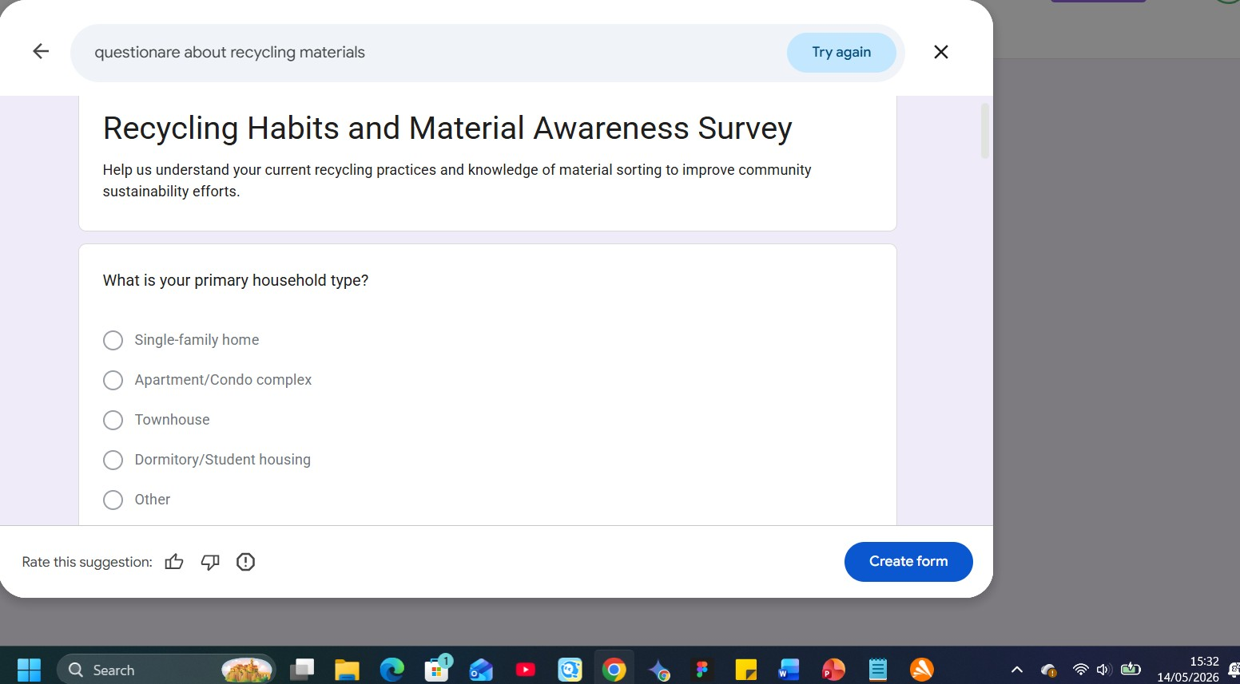
Figure 1example to test out how Google Forms generate questionnaires
- Can modify, edit, add and format the questions and answers with various tools
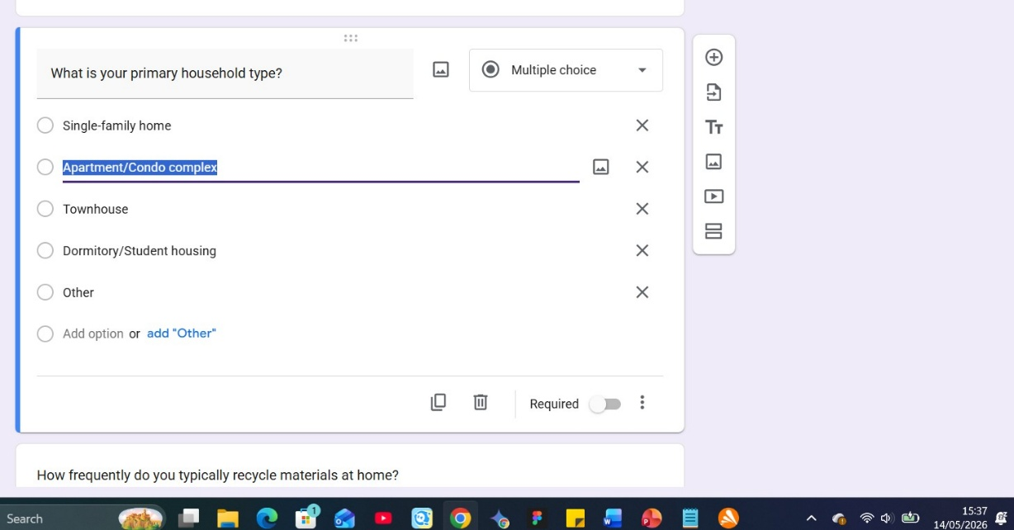
Figure 2 example to show editing/formatting questions
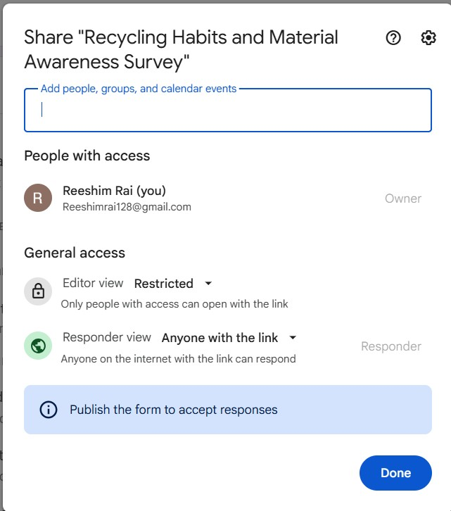
Figure 3 publishing and sharing the quiz/survey
Strengths- effective tool for data collection and standard quizzes, users can customize themes, fonts, and headers, forms can be shared with collaborators to build together
Limitations
- cannot fulfil the game storyboard mapped out for the game objective,
- visualisation and UX choices don’t apply when using software like Google forms or similar quiz-based platforms, hence lack of immersion and cognition
- it follows linear and ‘form-like’ structure
- limited visual feedback leads to barrier in learning; quiz in Google forms work like an exam paper and results are shown at the end of the form. The feedback we’re targeting is the immediate one; ‘just-in-time’ learning method to provide alert and make logic work like an impactful pop-up
- cannot update images dynamically, lower engagement
- overall text-based architecture hence restrictions in UI/UX, custom styling

HTML, CSS, JavaScript
- Suitable for web-based game, allows to fully realize the interactive and visual elements we’ve planned

Strengths
- web tools let us implement the exact interface we’ve created in out storyboard
- custom layouts- with CSS, creating and replicating buttons, icons layouts
- visual fidelity – high-quality assets are displayed with proper impact
- immediate feedback – instant engagement and feedback and result, visually understandable designs
- animation progress – use animation tags in CSS and use JavaScript to create interactive CTAs
- instant and quick access to game through a browser link and easy shares
- responsive design- game scalability and storyboard layout remains clear so users can access it through laptop, tablet or phones
- logic integration - web-based tool makes it simple to include the specific "tips and feedback
Overall, while selecting tools for our game development project we’ve decided to finalise web-based tool i.e. HTML, CSS, JavaScript as the most suitable one. Our target audience is aimed at university students and young teenagers hence much work relies on the development of UI/UX part of the game project. We will be focusing on the visuals and interactive elements of the game while the main cyber security objective remains as the main priority.
Focusing on the quiz-based game concept of the game, CSS and JavaScript allows to create clear and dynamic visuals for the audience to engage with. While the game logic would be easy enough for students to do the playthrough, the immediate response with correct or wrong answer and feedback allows smooth experience for the users. The simple ‘gain points-gain rewards’ makes more sense with clear visualisation of the said ‘points’ and ‘rewards’; here we can use various attributes to create buttons, actions, animations and icons.

